**Question 1**: *Provide a screenshot of the preview image. Does the image contain any cloud cover? How do you know this? Describe the spatial characteristics of the image selected. Would you consider the image selected a high resolution or low-resolution image in regards to spatial resolution? Why? Provide a possible application for this data*.

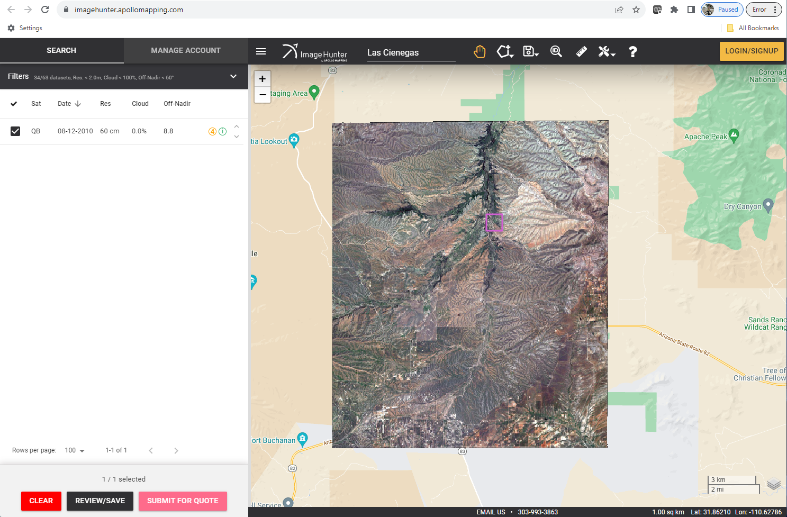

The image has no cloud cover because the cloud percentage is 0.0% under the preview attributes. The coverage area is 19.93 by 16.89km. The preview attributes indicate that the image has a high resolution of 60 cm but when you zoom in on the preview image, the resolution is not high. The high resolution is provided after downloading. It can used for land use or water shed mapping.

**Question 2**: *Unstack bands 3 and 4 and take a screen shot of each image for your report. Include a caption for each. Fill in the table below by indicating what general land cover types appear bright/dark in band 3 and band 4. Explain why these land cover types appear the way they do in the two bands*.

|  |  |  |
| --- | --- | --- |
|  | **Bright** | **Dark** |
| **Band 3** | Bare soil is bright | Vegetation especially around the river is dark |
| **Band 4** | Vegetation is bright in the near infrared | Bare soil is dark. |

Layout of Quickbird images with Raw Digital Numbers.

|  |  |
| --- | --- |
| Band 3 | Band 4 |
|  |  |

**Question 3**: *Take a screenshot of the final Radiance images for bands 3 and 4. Include a caption for both. What are the units of the Radiance image pixel values? Examine the file sizes of the final radiance images and the initial DN images. Which of the files is larger? Why is this so?*

The units of the radiance image pixel values are in “W-m2-sr-1μm-1” .

The file size for each band of spectral radiance is larger than the original DN files this can be because the original files were compressed into .tif images while the Radiance image is still in the raw .adf format.

Layout of Final Radiance Quickbird images.

|  |  |
| --- | --- |
| Band 3 | Band 4 |
|  |  |

**Question 4**: *Provide screenshots of reflectance images of band 3 and 4 and label them clearly with legends and short captions. Why do we want to work with reflectance data compared to Digital Numbers or Radiance?*

**Reflectance** is a fixed characteristic of the surface while DN values are raw recordings from a satellite that can change as a function of radiometric resolution. Since radiance is a measure of the absolute brightness observed at the sensor, and it can change depending on sun illumination or spectral band widths, it is not good for analysis.

Layout of Apparent Reflectance Quickbird images.

|  |  |
| --- | --- |
| Band 3 | Band 4 |
|  |  |

**Question 5**: *Why do the Landsat and QuickBird data need to be extracted at the same resolution to do the cross-calibration? Would it be important to select homogeneous areas in Landsat and QuickBird data to do this cross-calibration?*

*Provide screenshots of the resampled QuickBird apparent reflectance images of band 3 and 4 and caption them clearly.*

The Landsat and Quickbird data need to extracted at the same resolution to ensure accuracy of the cross-calibration. Because Quickbird data is of a higher resolution than Landsat, down sampling it is better than trying to upsample the low-res. Landsat image. To ensure accuracy of the cross-calibration, it is important to crop the Landsat image to the dimensions of the Quickbird data area because the Landsat covers a wider area.

Layout of Quickbird Resampled Apparent Reflectance to 30x 30 Landsat Resolution images.

|  |  |
| --- | --- |
| Band 3 | Band 4 |
|  |  |

**Question 6**: *If the QuickBird data and Landsat data both represent percent reflectance what is the Landsat data scaled by? Using the tables below, create linear equations for each band correlating the provided Landsat based-reference targets (dark and bright) and QuickBird pixels. Make sure the QuickBird pixels are used as the x-values. If you need help creating a scatterplot with a linear trend line watch this video (https://youtu.be/nnM-7Q6gmUA). Provide the equations for each band*.

The Landsat data is scaled by 10000.

Band 1 | Equation (Joses): y = 3826x + 10.969

|  |  |  |
| --- | --- | --- |
|  | QB_Resam_App_Refl | Landsat |
| Vegetation | 0.096289 | 363 |
| Vegetation | 0.096289 | 373 |
| Vegetation | 0.092295 | 321 |
| Barren Land | 0.112707 | 481 |
| Barren Land | 0.118919 | 528 |
| Barren Land | 0.127793 | 521 |
| Roads | 0.148205 | 609 |
| Roads | 0.144211 | 415 |
| Roads | 0.165067 | 479 |
| Structures | 0.123356 | 430 |
| Structures | 0.120694 | 513 |
| Structures | 0.156636 | 847 |

Band 2 | Equation (Joses): y = 3790.3x + 303.18

|  |  |  |
| --- | --- | --- |
|  | QB_Resam_App_Refl | Landsat |
| Vegetation | 0.086475 | 560 |
| Vegetation | 0.097035 | 667 |
| Vegetation | 0.093039 | 670 |
| Barren Land | 0.122149 | 801 |
| Barren Land | 0.126716 | 864 |
| Barren Land | 0.142413 | 894 |
| Roads | 0.159536 | 895 |
| Roads | 0.148691 | 671 |
| Roads | 0.179799 | 767 |
| Structures | 0.108736 | 703 |
| Structures | 0.113873 | 768 |
| Structures | 0.171238 | 1252 |

Band 3 | Equation (Joses): y = 3900.5x + 266.36

|  |  |  |
| --- | --- | --- |
|  | QB_Resam_App_Refl | Landsat |
| Vegetation | 0.063603 | 510 |
| Vegetation | 0.068527 | 503 |
| Vegetation | 0.069348 | 505 |
| Barren Land | 0.160034 | 916 |
| Barren Land | 0.156341 | 968 |
| Barren Land | 0.206403 | 1103 |
| Roads | 0.177268 | 995 |
| Roads | 0.157572 | 674 |
| Roads | 0.221175 | 700 |
| Structures | 0.101765 | 673 |
| Structures | 0.123103 | 862 |
| Structures | 0.217892 | 1508 |

Band 4 | Equation (Joses): y = 1899.9x + 2351.9

|  |  |  |
| --- | --- | --- |
|  | QB_Resam_App_Refl | Landsat |
| Vegetation | 0.240569 | 3068 |
| Vegetation | 0.371189 | 3234 |
| Barren Land | 0.262119 | 2949 |
| Barren Land | 0.255962 | 2771 |
| Barren Land | 0.296863 | 2669 |
| Roads | 0.288947 | 2416 |
| Roads | 0.195710 | 2343 |
| Roads | 0.283229 | 3269 |
| Structures | 0.100274 | 2700 |
| Structures | 0.135018 | 2628 |
| Structures | 0.286748 | 2985 |

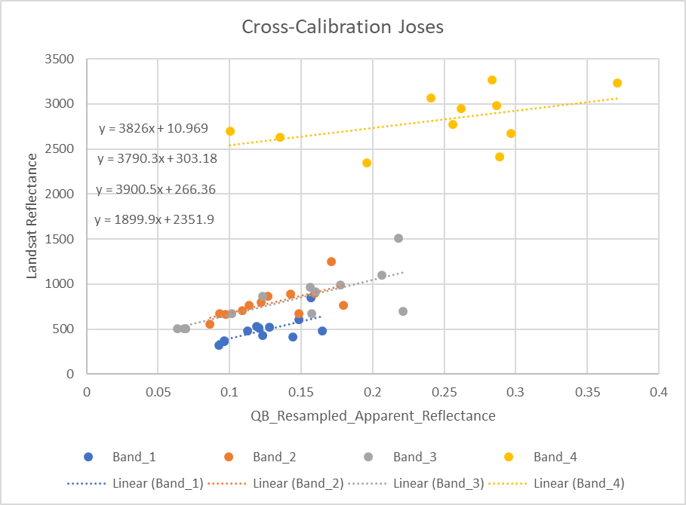 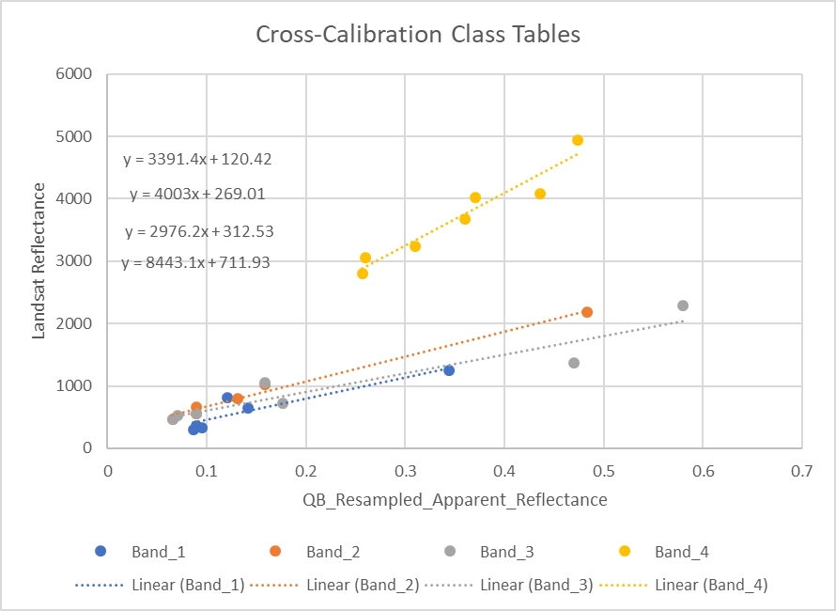

Calibration plots using manually selected data (left) and class data (right).

**Question 7**: *Apply the cross-calibration equations to the QuickBird images and compute surface reflectance*.

Equation Band 1 Class Data: y = 3391.4x + 120.42

Equation Band 2 Class Data: y = 4003x + 269.01

Equation Band 3 Class Data: y = 2976.2x + 312.53

Equation Band 4 Class Data: y = 8443.1x + 711.93

Layout of Quickbird Resampled Surface Reflectance that was resampled to 30 x 30 to fit Landsat resolution images.

|  |  |
| --- | --- |
| Band 3 | Band 4 |
|  |  |

**Question 8**: *How well do the spectral signatures of Landsat and QuickBird compare after the cross-calibration? How well do NDVI values compare between the two scenes? How do these QuickBird data complement the Landsat data in the context of a land cover study? Describe how you think these data can be used as part of Cienegas Creek’s monitoring and management activities*.

The spectral signatures of both datasets improve after cross calibration. See plots below.

The calculated NDVI values from both datasets are very similar. With a cross-correlation value of 82%.

|  |  |  |
| --- | --- | --- |
| **Avg. NDVI from 3 points** | **Quickbird** | **Landsat** |
| **Vegetation** | 0.697 | 0.691 |
| **Barren Land** | 0.563 | 0.454 |
| **Mixed Land** | 0.643 | 0.588 |

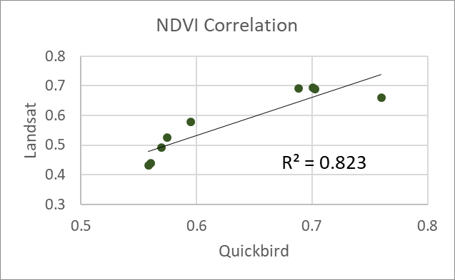

Quickbird provides a higher resolution data than Landsat that can be used to investigate local changes in NDVI that the Landsat data cannot resolve. This data can be used for land planning purposes to determine optimal locations for farmland, residential planning etc.

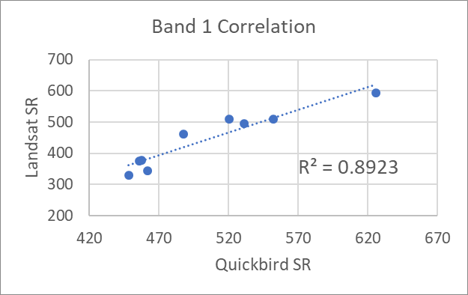 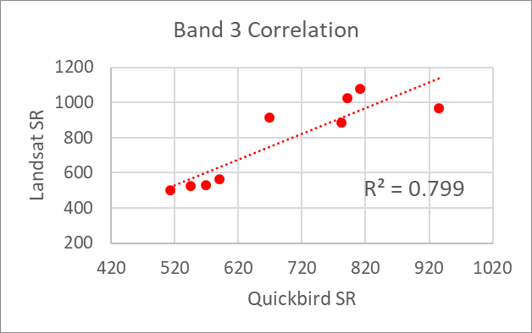

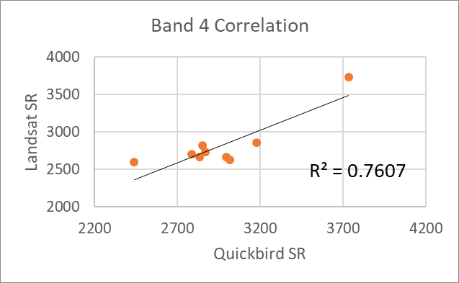

Cross-correlation plots of Quickbird surface reflectance vs. Landsat surface reflectance after cross calibration. The correlation ranges from 76-89 % across the three bands that were analyzed.